**E210 – Operations Planning**

**ESE Workshop Questions (23 Aug 2018)**

**Please remember to review workshop questions for MSA**

**Question 1**

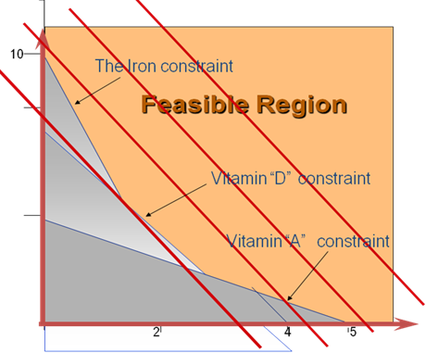

1. If the above problem is a minimization problem, identify the optimal solution. Which constraints are binding? Which constraint is not binding?
2. If the above problem is a maximization problem, is there an optimal solution?
3. Consider the following graph with the objective function line and the constraints shown below.

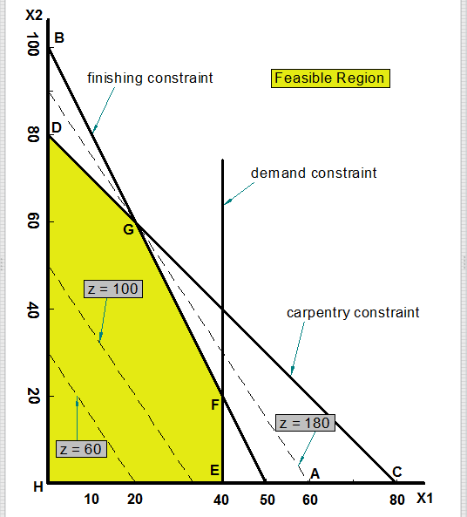

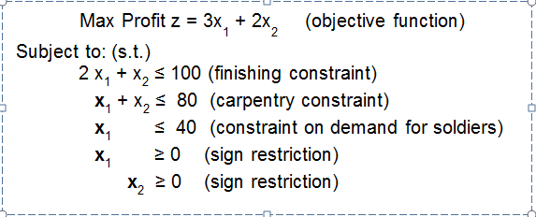

According to the LP formulation given above, identify the optimal solution and the corresponding objective function value. Identify the constraints that are binding and the constraint that is not binding.

**Question 2**

A factory manufactures three models of a product, which requires three resources – labor, material, and administration. The unit profits of these products are $1000, $600, and $400 respectively. There are 1200 hour of labor, 6000 kg of material and 3000 hour of administration available per month. The resource requirements for the products to manufacture are given in the table below.

|  |  |  |  |  |
| --- | --- | --- | --- | --- |
| **Products** | **Labor (hour)** | **Material (kg)** | **Administration (hour)** | **Unit Profit ($)** |
| **Model 1** | 5 | 50 | 10 | 1000 |
| **Model 2** | 5 | 20 | 10 | 600 |
| **Model 3** | 5 | 25 | 30 | 400 |
| **Available Resource** | 1200 | 6000 | 3000 | - |

Formulate a linear programming model for this problem

**Question 3**

You have three investment options. The returns from the investment under different economic conditions are given in the following payoff table.

|  |  |  |  |
| --- | --- | --- | --- |
| **Investment Options** | **Economic Condition** | | |
| Favorable (40%) | Stable (40%) | Unfavorable (20%) |
| Option 1 | 8000 | 3000 | -500 |
| Option 2 | 3000 | 1800 | 1000 |
| Option 3 | 3800 | 2200 | 600 |

1. Which investment option should you go for based on the EMV method?
2. What is the EVPI?
3. If you want to choose the investment option based on a utility function:

U(x) = 1 – e –x/R with R = 500

1. Construct the utility table.

Utility Table

|  |  |  |  |
| --- | --- | --- | --- |
| **Investment Options** | **Economic Condition** | | |
| Favorable (40%) | Stable (40%) | Unfavorable (20%) |
| Option 1 |  |  |  |
| Option 2 |  |  |  |
| Option 3 |  |  |  |

1. What will be your investment option based on the expected utility?
2. Compare your decisions made based on the EMV and the expected utility, are they the same? What is the advantage of using expected utility in decision making?
3. With the utility function U(x) = 1 – e –x/R, what is your risk attitude? What do you call R? If your friend also uses the utility function U(x) = 1 – e –x/R with R = 100, comment on his risk attitude in comparison with yours.

**Question 4**

You are given two alternatives in a game show.

Alternative 1: receive $100 and leave the game

Alternative 2: play the game where if you win, you receive $1000; if you lose, you pay $400. The probability that you win is p.

1. What is the certainty equivalent to alternative 2?
2. If you think that the two alternatives are indifferent when p is 0.4, what is your risk premium? What is your risk attitude? Explain.
3. If your friend Amy thinks that the two alternatives are indifferent when p = 0.3, what is her risk premium? What is her risk attitude? Explain.
4. Determine p for a person who is risk neutral.

**Question 5**

A company has two manufacturing plants A and B. The plants can supply the following numbers of products to the company’s distributors each month:

|  |  |
| --- | --- |
| **Plant** | **Monthly Supply (unit of products)** |
| A. | 5800 |
| B. | 5400 |
| Total | 11200 |

The distributors which are spread throughout five countries have the following total monthly demand:

|  |  |
| --- | --- |
| **Distributor** | **Monthly Demand (units of product)** |
| 1 | 2600 |
| 2 | 3050 |
| 3 | 2300 |
| 4 | 1800 |
| 5 | 1450 |
| **Total** | 11200 |

The company must pay the following shipping cost per unit of the product:

|  |  |  |  |  |  |
| --- | --- | --- | --- | --- | --- |
| **From** | **To (cost, $)** | | | | |
| **1** | **2** | **3** | **4** | **5** |
| **A** | 12 | 15 | 17 | 14 | 16 |
| **B** | 9 | 7 | 10 | 6 | 18 |

1. What is the objective of the above product distribution problem?
2. Formulate a Linear Programming (LP) model for the product distribution problem. When using Excel Solver to find the optimal solution based on the LP method, do you need to add in the integer solution requirement on the decision variables? Justify your answer.

**Additional practice:**

What if demand from distributor 1 increases from 2600 to 3000?

What if supply from Plant A increases from 5800 to 6000?

**Question 6**

1. Table below shows the hobby codes of your friends.

|  |  |
| --- | --- |
| **Friend** | **Hobbies** |
| **A** | **3, 8, 10, 14, 15** |
| **B** | **2, 3, 7, 8, 9, 12, 13, 15** |
| **C** | **3, 5, 10, 14** |
| **D** | **2, 7, 8, 11, 12, 13** |
| **E** | **1, 4, 5, 9, 10** |
| **F** | **2, 5, 7, 8, 9, 10** |
| **G** | **3, 4, 15** |
| **H** | **4, 10** |
| **I** | **1, 6** |

1. Determine the dissimilarity index between your fiends A and B
2. Determine the dissimilarity index between your fiends A and C
3. Based on the table given, you want to plan a seating arrangement using the minimum spanning tree model.
4. What are the arcs in the minimum spanning tree model?

1. What are the nodes in the minimum spanning tree model?

1. What is your objective when linking your friends based on the minimum spanning tree model?

1. You are given the following dissimilarity index table:

|  |  |  |  |  |  |  |
| --- | --- | --- | --- | --- | --- | --- |
| Friends | D | E | F | G | H | I |
| D | - | 1 | 0.666667 | 1 | 1 | 1 |
| E | 1 | - | 0.625 | 0.857143 | 0.6 | 0.833333 |
| F | 0.666667 | 0.625 | - | 1 | 0.857143 | 1 |
| G | 1 | 0.857143 | 1 | - | 0.75 | 1 |
| H | 1 | 0.6 | 0.857143 | 0.75 | - | 1 |
| I | 1 | 0.833333 | 1 | 1 | 1 | - |

1. To construct the minimum spanning tree, you started with node E, and linked E with H as ‘H’ is the ‘closest’ to E in terms of the dissimilarity index.
2. Which method are you using to construct the minimum spanning tree?

1. What is the next node to be linked to the partial minimum spanning tree you constructed? How do you link the node to the partial minimum spanning tree? Justify your answer.
2. Write down the solution in pairs of connections and in order of sequence if you apply the Kruskal’s algorithm to construct the minimum spanning tree.
3. List two criteria you can use to put your friends into different tables.

**Question 7**

An oil company, OIL, owns a tract of land that may contain oil. The chance that the land contains oil is 0.25. Because of this prospect, another oil company has offered to purchase the land for $90,000. However OIL is considering holding the land in order to drill for oil itself. If oil is found, the expected profit is $700,000. However, if the land is dry, a loss of $100,000 will be incurred. Another option prior to making a decision is to conduct a detailed seismic survey to obtain a better estimation of the probability of finding oil at the cost of $30,000.

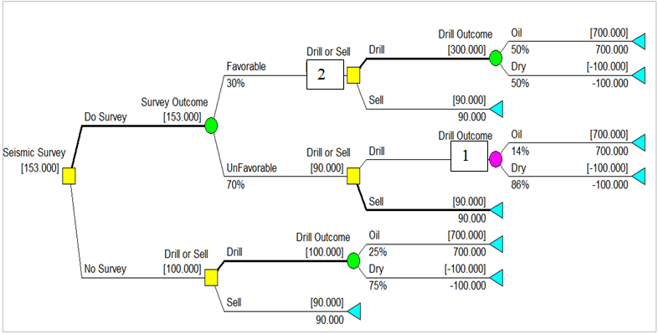Figure below is the decision tree generated by DPL for the above decision making problem.

1. Calculate the EMV value when Seismic survey outcome is ‘UnFavorable’ and the decision is to ‘Drill’ labeled as ‘1’. Show your workings.

1. When seismic survey outcome is ‘Favorable’, what is your recommendation for the ‘Drill or Sell’ decision? What is the decision value associated with this decision? Show your workings clearly.

1. Should the company conduct the seismic survey at the cost of $30,000? Justify your answer with workings.

1. Calculate EVPI and the efficiency of sample information. Show your workings clearly.

1. State the overall best course of action the company should take. What is the total expected profit associated with the best course of action?

**Question 8**

Several oil companies are jointly planning to build an oil pipeline to connect several south-western, south-eastern, and Midwestern cities, as shown in the following network:

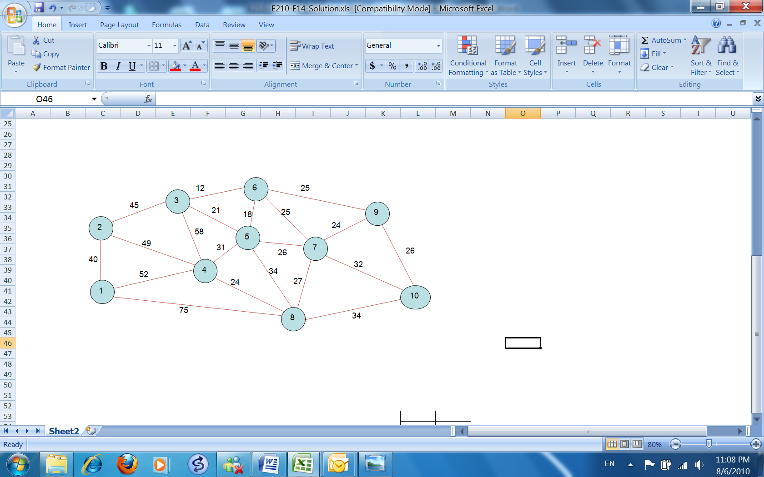

The distances (in kilometer) between cities are shown on each branch. Determine a pipeline system using the following algorithms that will connect all 10 cities, using the minimum number of miles of pipe, and indicate how many miles of pipe will be used.

1. Prim’s Algorithm (starting from node 9)
2. Kruskal’s Algorithm
3. Draw the Minimal Spanning Tree
4. If the cost of building the pipe network is $80 thousand per kilometer and the oil companies only catered 20 million for this project, will the oil companies be able to proceed with the project? Explain.

**Question 9**

A large bank is going to make one of three investments. The economy will have one of three possible states during the life of the investment: improve, remain stable, or worsen. The trust officer believes the respective probabilities are 0.1, 0.5, and 0.4. The estimated payoff table is as follows:

|  |  |  |  |
| --- | --- | --- | --- |
| Investment | Improve | Remain stable | Worsen |
| A1 | 30 | 5 | -10 |
| A2 | 40 | 10 | -30 |
| A3 | -10 | 0 | 15 |

1. Determine the optimal action based on the EMV method
2. Calculate the EMV with perfect information and EVPI.
3. If the trust officer makes his decision based on the following utility functions, determine the optimal action to take under each scenario based on the expected utility.

* U(x) = x1/3
* U(x) = 2x + 6

**Question 10**

A form teacher of primary six wants to assign his 8 students to 3 interest groups taking into account student attributes and their preferences. There are certain constraints on the composition of each group. Each group must contain a certain minimum number of female students and certain minimum numbers of students who are good at the following subjects: Math, Science, and English. Here is a table with the 3 groups and their student requirements:

Table 1: Group requirements

|  |  |  |  |  |
| --- | --- | --- | --- | --- |
| **Group Number** | **Size of Group** | **Minimum Number of Students Good at Math** | **Minimum Number of Students Good at Science** | **Minimum Number of Students Good at English** |
|
| #1 | 2 | 1 | - | 1 |
| #2 | 3 | 2 | 1 | 1 |
| #3 | 3 | 1 | - | 2 |

Here is a table listing students’ preferences and their attributes:

Table 2: Student Attributes and their preference

|  |  |  |  |  |
| --- | --- | --- | --- | --- |
| **Student Name** | **Group Preference** | | | **Subjects good at** |
| **#1** | **#2** | **#3** |
| 1 | 3 | 2 | 1 | English |
| 2 | 2 | 3 | 1 | Math, English |
| 3 | 1 | 3 | 2 | Science |
| 4 | 1 | 3 | 2 | Math, English |
| 5 | 3 | 1 | 2 | Math, Science |
| 6 | 2 | 3 | 1 | English |
| 7 | 2 | 1 | 3 | Math, Science |
| 8 | 3 | 2 | 1 | English |

‘1’- Preferred; ‘2’- preferred; ‘3’-Not Preferred

The form teacher also understands that students 1 and 5 must be in the same group; either student 4 or 6 must be in group 2 and; students 6 and 8 cannot be together.

Formulate a binary integer programming (BIP) model for the above problem.